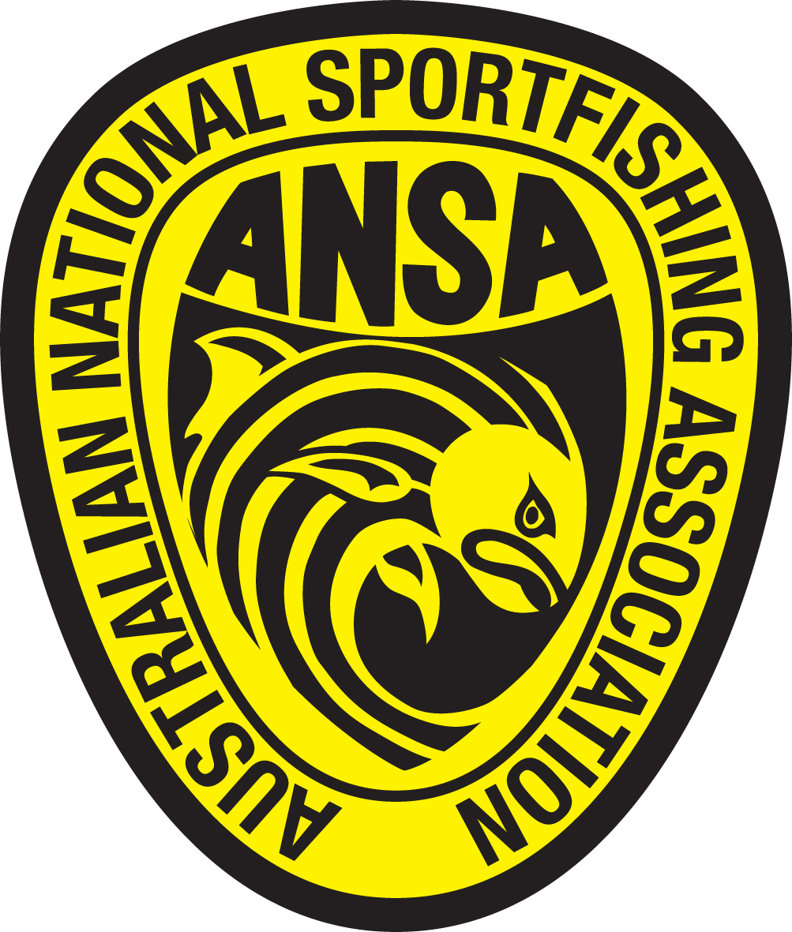
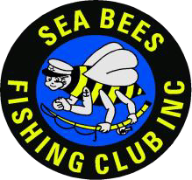
Sea Bees Fishing Club Inc
Lake Lyell (Lithgow) ANSA Convention 17th May – 19th May 2024
ENTRY FORM

Participating Club:

We have read the entry conditions.

Competitors Name: ANSA Member (Y/N). ANSA Mem No. $ Entry Fee Signature:
1. ------------------------------------------------------------------------------------------
2. ------------------------------------------------------------------------------------------
3. ------------------------------------------------------------------------------------------
4. ------------------------------------------------------------------------------------------
5. ------------------------------------------------------------------------------------------
6. ------------------------------------------------------------------------------------------
7. ------------------------------------------------------------------------------------------
8. ------------------------------------------------------------------------------------------
9. ------------------------------------------------------------------------------------------
10. ----------------------------------------------------------------------------------------
Total Numbers: Senior …… Junior …… Total $..................
DECLARATION:
I/We wish to participate in the Sea Bees Fishing Club Inc. 2024 ANSA Lake Lyell Convention and agree to participate entirely at my/our own risk. I/We agree to abide by the rules as set down and are aware that the Sea Bees Fishing Club Inc. President, Committee Members and Convention Organisers will not be responsible or liable for any loss or damage to any person, property, personal injury or death, during the Convention.
Entry fees:
Senior $45, juniors accompanied by paid parent, free.
This fee does not include park entry or camping fees
Please forward a signed & completed form to:
Sea Bees Fishing Club Inc.
The Treasurer, Sea Bees Fishing Club Inc.
P.O. Box 1432, Baulkham Hill NSW. 1755
Fees can be paid via:
- via the online registration at seabeesfishingclub.com/lake-lyell
Credit/debit card or PayPal accepted
- Direct credit detail:
Sea Bees Fishing Club Inc.
National Australia Bank
BSB 082155 Account: 037157319
Please include name & Club so we can reconcile payments.

Closing date Sunday 3rd May 2024
Late entries may be accepted at the Clubs discretion. $5.00 late fee applies;

Enquiries: Rob Sinclair (Treasurer): e-mail: Rob3939@icloud.com Ph: 0487017018
Web site: www.seabeesfishingclub.com.

